How to view student information (and print reports)

Step 1: Visit https://cetsl.vsware.ie

Step 2: Use the username and password that you received by text to log in

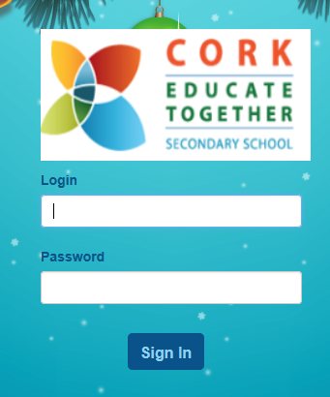

Step 3: Now you can access various types of data about your child (on the left hand side)
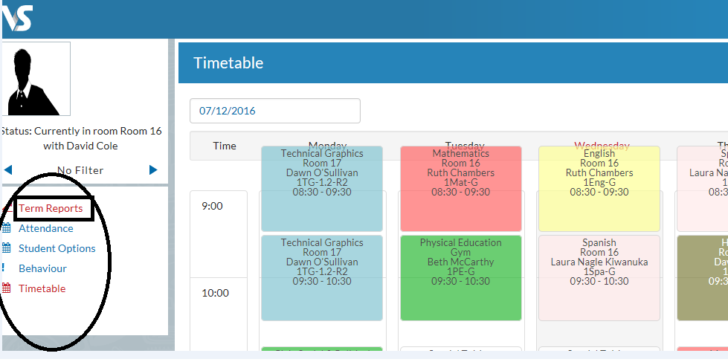
Step 4: If you want to see and print a report, click on ‘Term Reports

Step 5: Select an exam (e.g.- ‘2017/18 Trimester 2’)
Step 6: You will now see a list of subjects, such as the one below. This is a factual view of the data, but an ugly one. It’s better to move directly to step 7.

Step 7: Click ‘Actions’ on the top right, then click ‘Print’ and finally ‘Open’ or ‘Save As’.
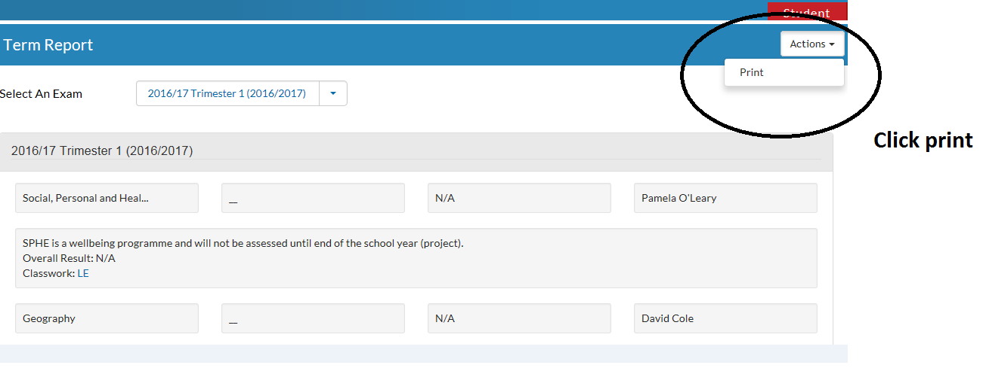

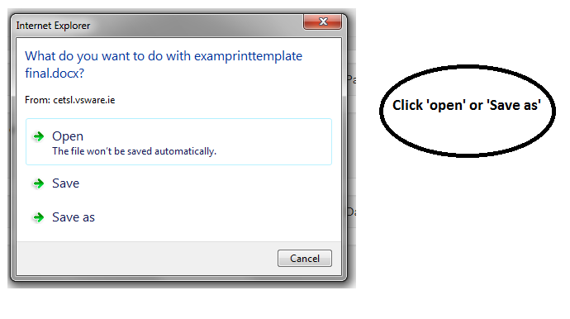
This will open a printable report, in a familiar format (see below).
N.B. Each subject has five sub-headings; each of which is graded by codes. These codes are listed as descriptors on the second page. The codes are all being used as part of the new Junior Cycle and so, whilst a bit unusual at first, they will become normal for you quite soon.
